**CAMERA SCANNER TESTING**

**Project Title: Project X**

**Prepared by: Team BAMP**

**Faculty of Computing, Engineering and Technology**

**Login Account**

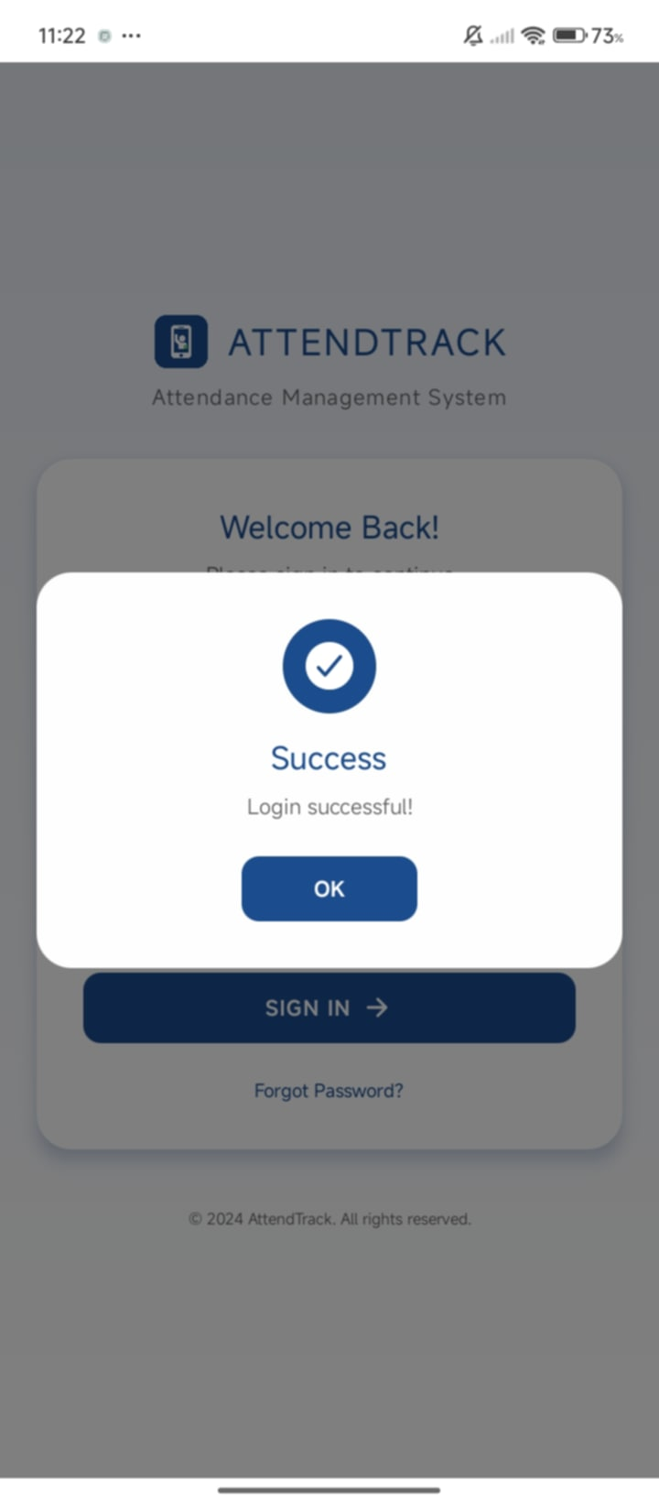

**Lecturer Dashboard**

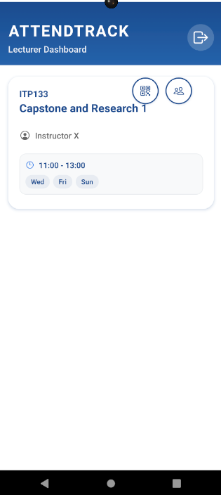

**Generate QR Code**

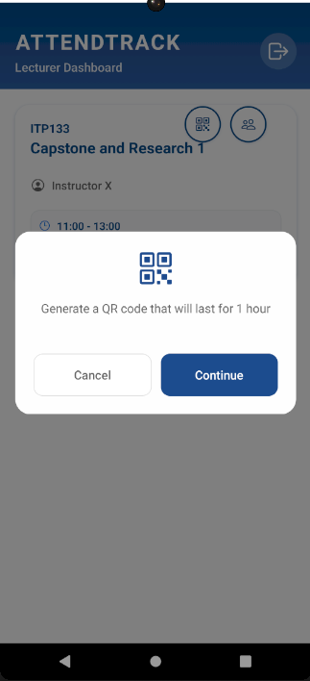

**QR Code for Scanning**

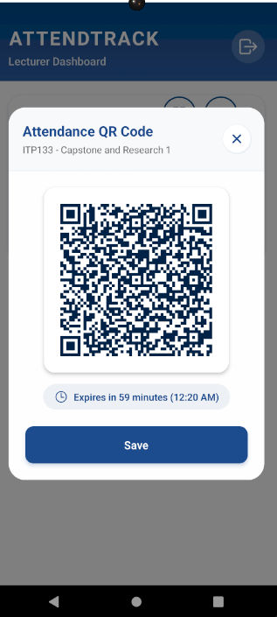

**Student Dashboard**

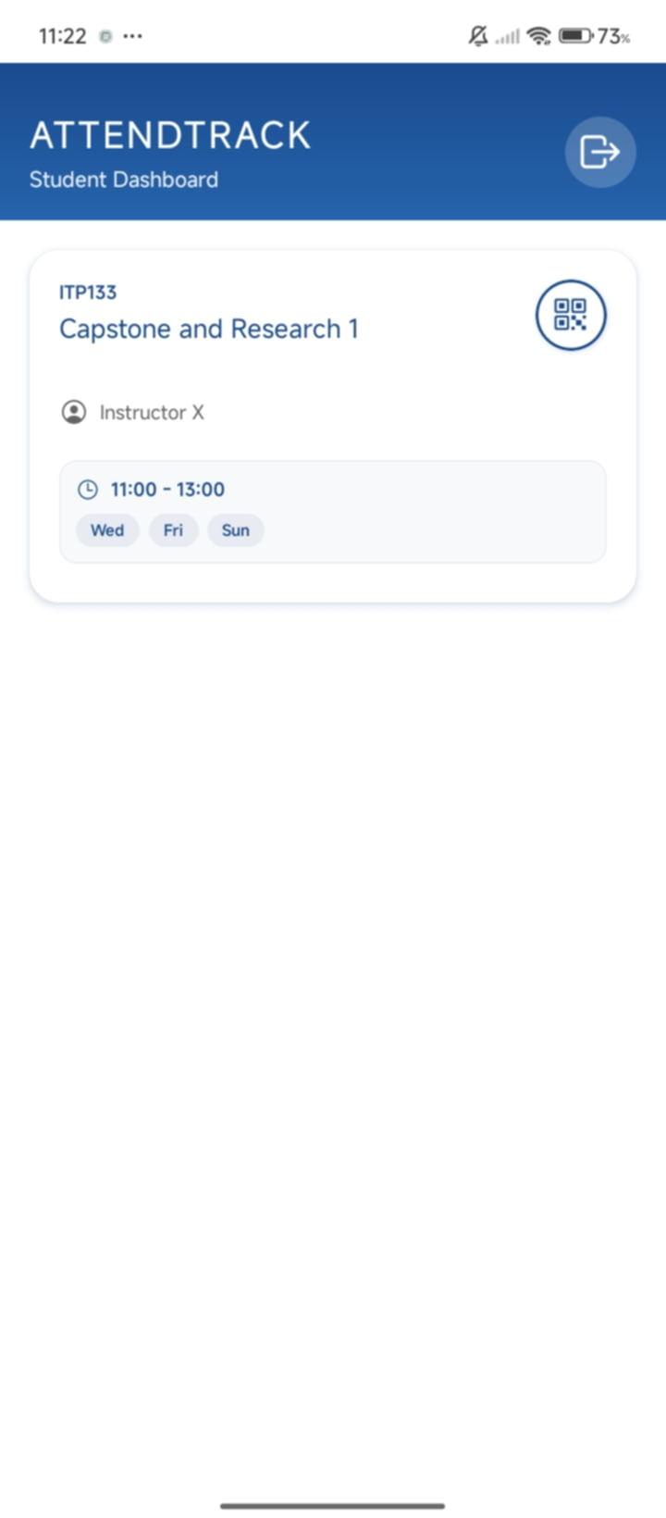

**Student QR Scanner**

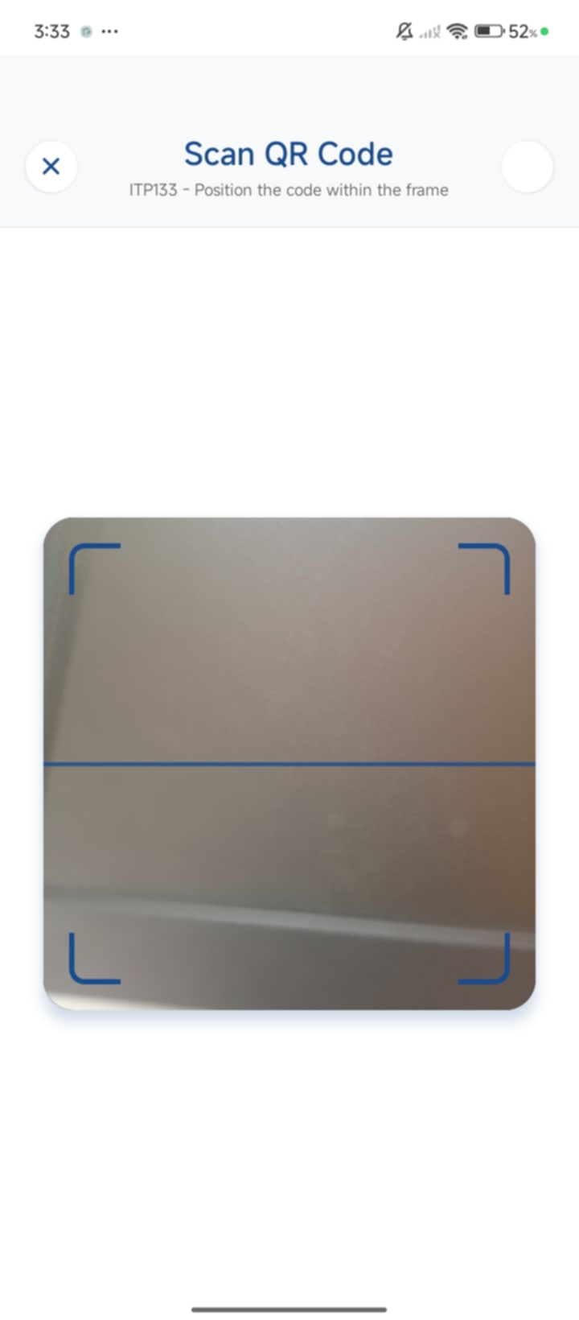

**Scan Successful**

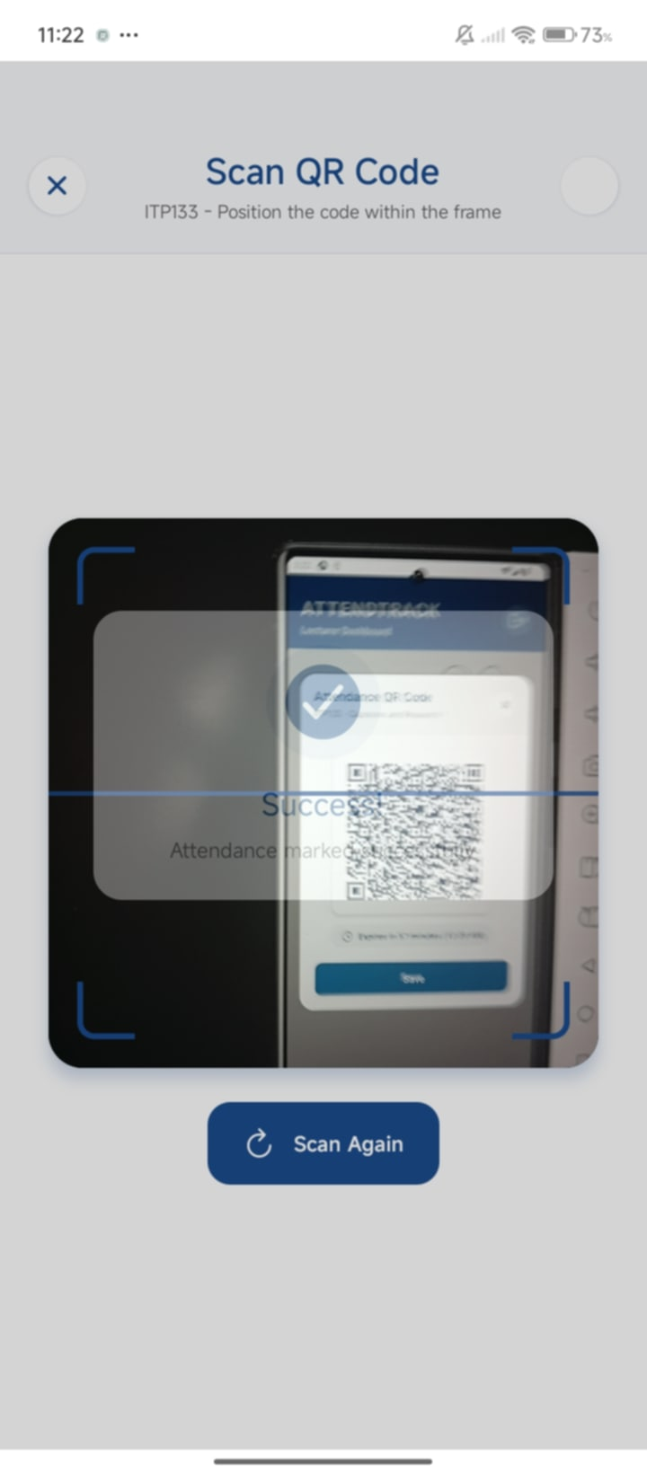

**Scanned Attendance Record in Database**

